**Chaktim Wong - 50280143**

**chaktimw@buffalo.edu**

**Group Number 75**

**API USED: “https://apidocs.cheapshark.com/#intro”**

* **Displays games in the Steam Library with their normal prices, current discounts, and more**

**Architectural Diagram:**

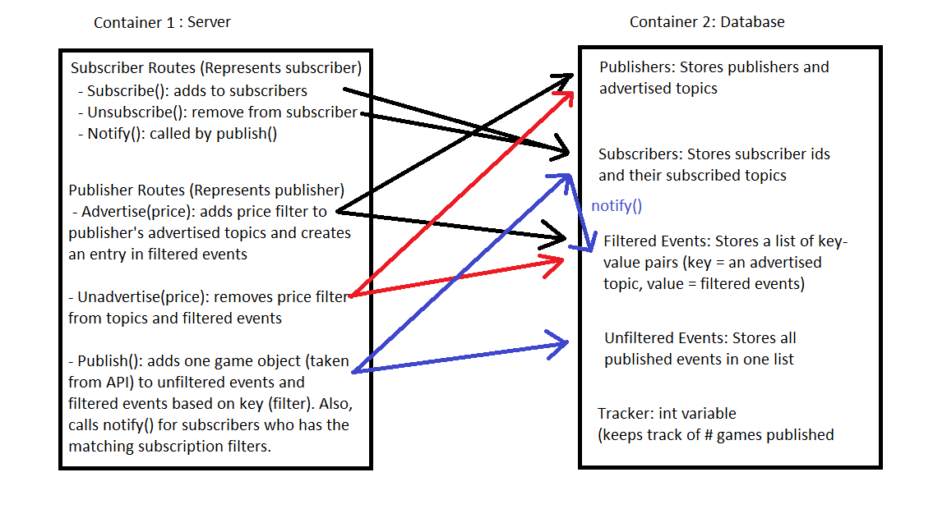

**Architecture: Type Based Sub/Pub System (Specifically, game prices)**

* **app.py**
  + **The server file**
  + **Contains all the routes for any http connection or socket connection**
  + **Stores socket connection (serves as user’s identifier)**
    - **Publishers and Subscribers field (can be accessed later)**
    - **Two-way connection with user**
* **Index.html**
  + **Two links: publisher.html and subscriber.html**
  + **Both links creates a socket connection with the server**
* **Publisher.html**
  + **User interface to manage advertisements and publishing**
    - **Advertise UI** 
      * **User field form with button**
    - **Unadvertise UI**
      * **User field form with button**
    - **Publish**
      * **Displayed most recent published game**
* **Subscriber.html**
  + **User interface to manage and view subscriptions**
    - **View advertised topics**
    - **Subscribe UI (input to user field and submit)**
      * **Only accepts advertised prices**
    - **Unsubscribe UI**
      * **Only accepts subscribed values**
    - **View published games** 
      * **Displayed after publisher publishes**
* **Database_tools.py**
  + **Database management API**
    - **Contains all the methods used to manipulate the database**
  + **Tested in test_database_tools.py**
* **Publisher_tools.py**
  + **Contains methods for publisher control**
* **Docker-compose.yml**
  + **Creates a database container and a python container (database is hosted online)**
* **Dockerfile**
  + **Establishes a python container**

**Startup Instructions:**

1. **Run Docker**
2. **Go to project file directory in cmd**
3. **Run command “docker-compose up”**
4. **Wait till docker finishes startup**
5. **Go to url: “localhost:8000”**
6. **Open both links (publisher, and subscriber)**
7. **Advertise at least 3 topics (Ex: 5, 10, 30) in publisher’s page. (It is possible to unadvertised these topics)**
8. **On the subscriber’s page, these topics should appear at the top**
   1. **Subscribe to them**
9. **On the publisher’s page, hit publish to publish one game from the api**
10. **These published games will display on the subscriber’s screen if they fall under their subscription filter (Under $5, Under $10, Under $30, etc.). No repeats.**